

**2018**

**2nd Annual Vancouver, WA. Umpire**

**90’ Outreach Clinic**

* Are you looking for a source to fine-tune your umpiring skills?
* Do you want to work-with and learn-from the best of the best?

**Washington District 4 Little League is hosting a**

**Western Region 90’ Accredited Umpire Mechanics Clini****c**

|  |  |
| --- | --- |
|  |  |
| Saturday, March 31 | 8 am to 5 pm |
| Sunday, April 1 | 8 am to 2 pm |

**Where:**

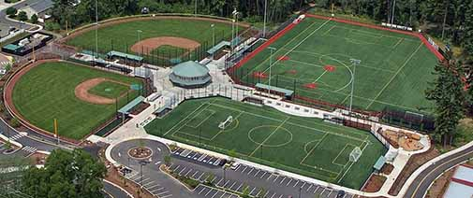 Luke Jensen Sports Park

4000 NE 78th St.

Vancouver, WA 98665



*Advanced registration is **REQUIRED**\*

Early registration (prior to March 15, 2018) per student is $75

Registration after March 15, 2018 is $100.00

To register, complete the attached Registration Form

**AGENDA**

|  |  |  |
| --- | --- | --- |
| Date | Time | Event |
|  |  |  |
| Saturday, March 31 | 8:00 am to 8:45 am | Registration - Bud Vane Cleve Community Room |
| Mechanics Instruction | 9:00 am to 5:00 pm | Field 1 (Lunch is Provided) |
| Sunday, April 1 |  |  |
| Mechanics Instruction - | 8:00 am to 2:00 pm | Field 1 |
| Graduation | 2:00 pm to 2:30 pm | Field 1 |
|  |  |  |

**NOTES**

Equipment: Bring any equipment you might want or need to survive a pitching machine throwing baseballs at you (all males MUST have a cup to work plate mechanics)

Clothing: Yes, this is the Pacific Northwest, so plan for cold, wet weather. Dressing in layers is highly recommended.

Registration: Please fill out the registration form COMPLETELY. Make checks out to **Washington District 4 Little League**.

Disclaimer: The events and venues are subject to change. You will be notified via email of any such changes.

Lodging: Quality Inn & Suites, 7001 N.E. Highway 99, Vancouver, WA. 98665. Please contact the Hotel directly at (360) 696–0516 and mention you are with the *Little League Outreach Umpire Clinic*. The room rate is $ 79 + Tax, for a two queen bed and a full Hot Breakfast. Rooms have microwaves and refrigerators.

Your Clinic UIC is Steve Christman.

Steve Christman at 209 – 418-9152 or Robert_christman54@yahoo.com

For clinic & logistics questions, contact:

Joe Loftgren at 503-201-0444 or [umpjoe13@gmail.com](mailto:umpjoe13@gmail.com) or

**2018**

**2nd Annual**

**Vancouver, WA. 90’ Outreach Clinic**

**Registration Form**

NAME: _____________________________________________________________________________

ADDRESS: ___________________________________________________________________________

CITY: ________________________ STATE: ____________ ZIP CODE: ________________

DAY PHONE: _____________________________ EVENING PHONE: _____________________________

E-MAIL : ______________________________________________________________________________

DISTRICT: _____________________________________________________________________________

PREVIOUS UMPIRE EXPERIENCE: ___________________________________________________________

A check for the appropriate amount of $75.00 must accompany this application by March 15, 2018. We will accept the first **30** students to register.

Please make check payable to: **Washington District 4 Little League**.

Please circle t-shirt size:

M L XL XXL XXXL XXXXL



Please mail registration form and check to

Joe Loftgren

Vancouver 90’ Outreach Clinic

12705 SE McGillivray Blvd.,

Vancouver, WA 98683

